**Test Analysis:** Tested over 200 episode

**Agent id:** default_LSTM_v1_2_283

**Action histogram:**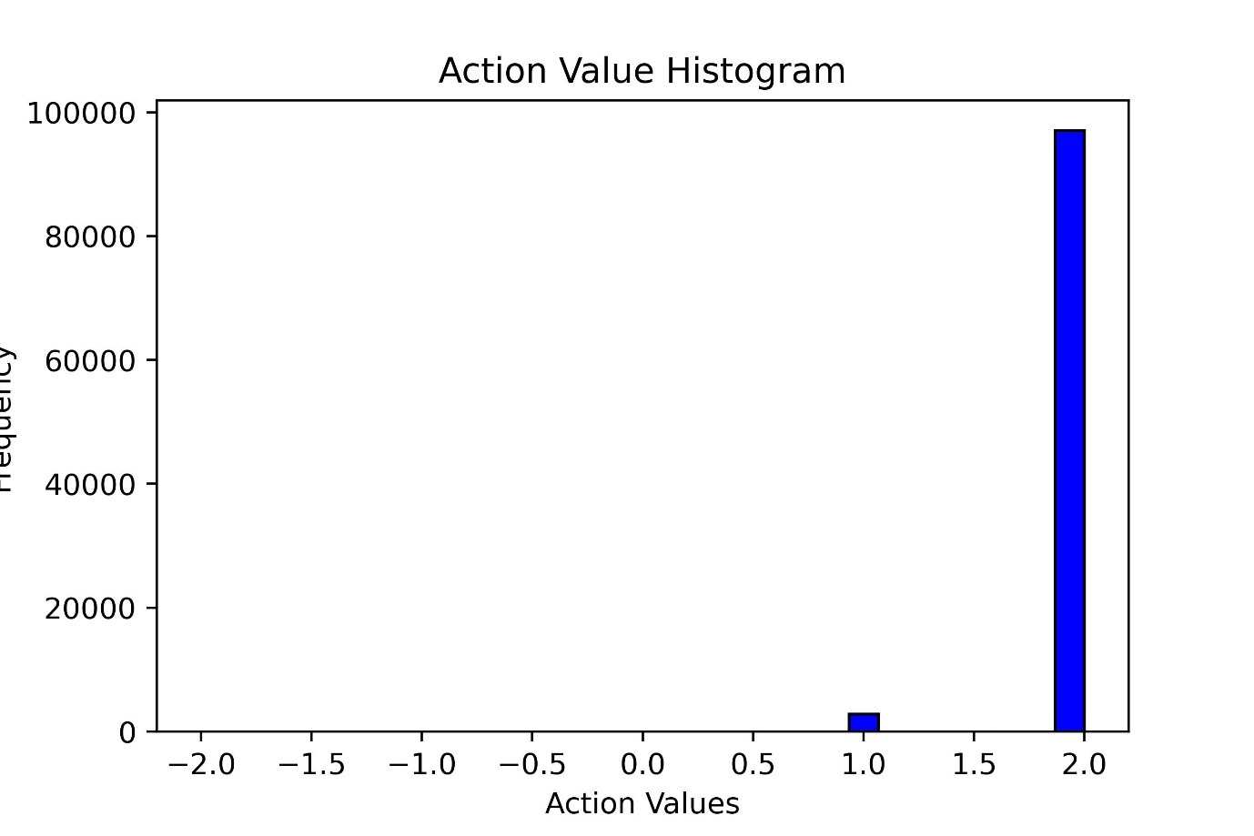

** The agent don’t know the difference between hold actions and other actions. Example: When money reserve is zero the sell action and hold action does same i.e., no change in fund or stock. But the agent don’t know the difference. I need to make a very small negative reward to encourage to hold most of the time and buy and sell only when required.

**Candle Plot:**   
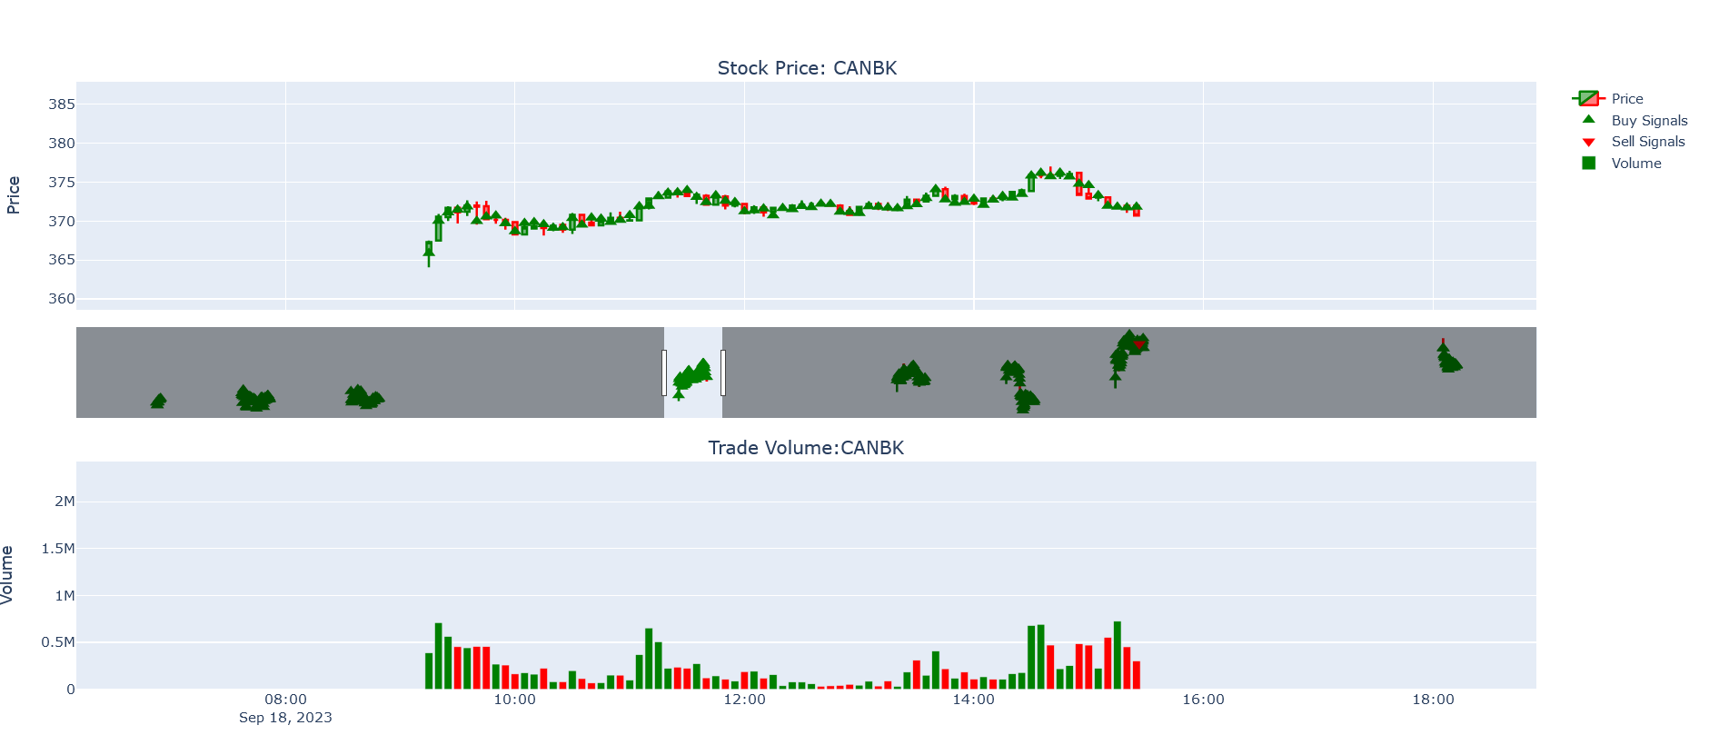

**Reward Histogram:**

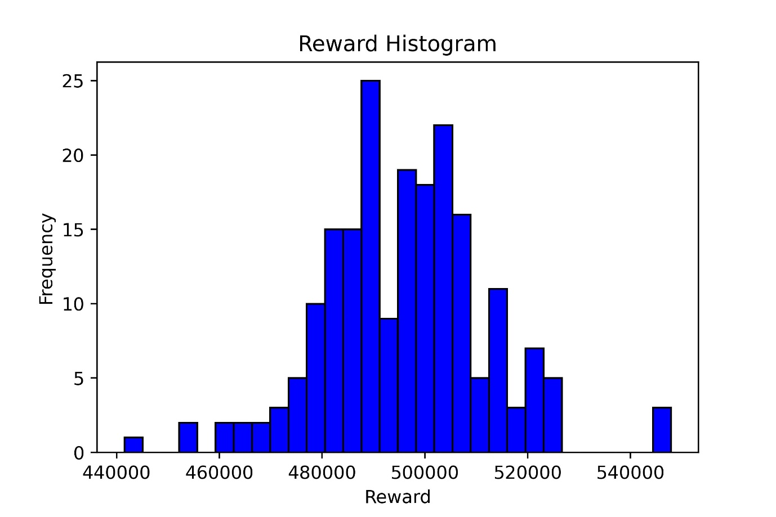

Clearly the Agent is not profitable